DISCLOSURE OF INVENTION

- Particulars of inventor(s)
S. No. | Name of the Inventor(s) | Organization / department and designation (if applicable) | Nationality | Email and Phone number
1 | Dr. Manish Kumar | Director,Graphic Era Hill University, Haldwani | India | Director.haldwani@gehu.ac.in
2 | Ms. Sujata Negi Thakur | Assistant Professor, Computer Science and Engineering, Graphic Era Hill University, Haldwani | India | sujatanegi@gehu.ac.in
3 | Mr. Manoj Kumar Singh | Assistant Professor, School of Computing, Graphic Era Hill University, Bhimtal | India | mthakur@gehu.ac.in
4 | Dr. Sumit Pundir | Assistant Professor, Department of Computer Science and Engineering, Graphic Era Deemed to be University, Dehradun | India | sumitpundir@geu.ac.in
5 | Ms. Gurpreet Kaur Jassal | Student, School of Computing, Graphic Era Hill University, Dehradun | India | gurpreetkaurjassal.bca.20042126@gehu.ac.in
6 | Mr. Deepankar Sharma | Student, Department of Computer Science and Engineering, Graphic Era Hill University, Haldwani | India | deepankarsharma.20041299@gehu.ac.in

- Kindly attach more sheets if required
- Please feel free to attach additional drawings if needed to explain your response(s). In addition, please attach any supplemental materials that you think might help illustrate your invention.

- Particulars of invention

- Title of the invention
An Application To Support Local Businesses and Dealers

- General purpose of the invention:

The Covid-19 outbreak made us realize that having an online presence is very important for any business. Most of the businesses in our country went crashing down since pandemic and , Although many businesses have switched to the online mode of business but still most of local businesses, dealers and small startups aren’t that much active in the terms of online business presence. Foreign MNCs are exploiting that for their personal benefits and because of this many of the local businesses remain unnoticed among the tough competition with the products of MNCs with heavy brand power.

- Flowchart, process, method, algorithm and diagram of the invention

USER

APPLICATION

LOCAL BUSINESS
DEALERS AND SUPPLIERS
MNCs

- Abstract

The idea is to develop an application where people would have better way to explore the local brands with more preference over the brands manufactured by foreign MNCs. The application will provide an abstract view of all the possible deals a customer could go for. The primary objective of this would be to support the Make In India Campaign. Whenever the user will search for any item, this app will go through the various e-commerce websites like amazon , flipkart , etc and also those of the local businesses and regional dealers/suppliers near to the user along with the reviews given. The user would get all in one necessary comparisons of products all in one place and user might select based on their interest. The app will also let the local dealers and suppliers to demonstrate their sales . In this way the local brands will get equally fair opportunity as any other brands. The users will be provided with a one-on-one chat to directly contact about the product from their nearest local sellers. The app would do all the heavy lifting for the user , by searching and aligning all the possible options they have at one place making it easy to do the comparision between them.

Signature of Applicant
Dt:
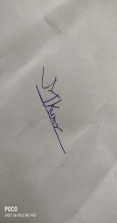


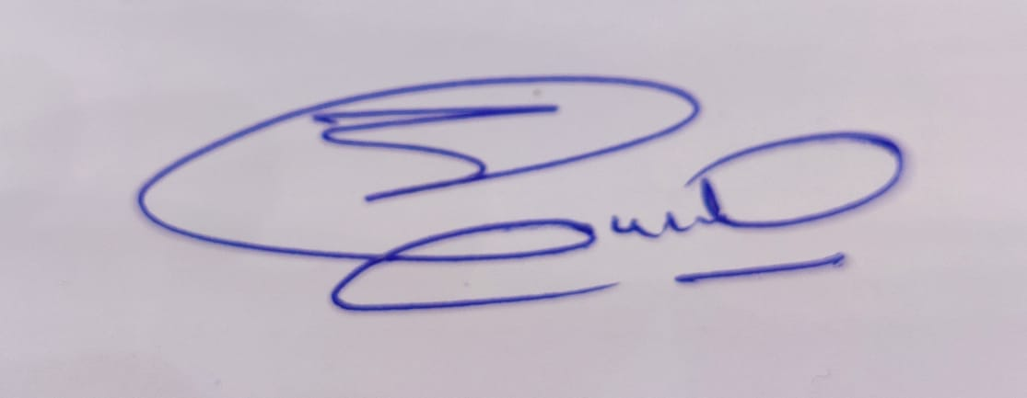
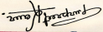


Remark of IP Cell

Signature IP Head

Remarks of Dean Office

Signature

